**DAILY ONLINE ACTIVITIES SUMMARY**

|  |  |  |  |  |  |  |  |  |
| --- | --- | --- | --- | --- | --- | --- | --- | --- |
| **Date:** | **05-06-2020** | | | | | **Name:** | **Nihal Rafiq** | |
| **Sem & Sec** | **4th A** | | | | | **USN:** | **4AL18CS052** | |
| **Online Test Summary** | | | | | | | | |
| **Subject** | | **----** | | | | | | |
| **Max. Marks** | | **----** | | **Score** | | | **----** | |
| **Certification Course Summary** | | | | | | | | |
| **Course** | **1. Python for Machine learning** | | | | | | | |
| **Certificate Provider** | | | **Great Learning Academy** | | **Duration** | | | **5 hours** |
| **Coding Challenges** | | | | | | | | |
| **Problem Statement:**  **1. Write a java program to find duplicate character in a string** | | | | | | | | |
| **Status: Executed** | | | | | | | | |
| **Uploaded the report in Github** | | | | | **Yes** | | | |
| **If yes Repository name** | | | | | **https://github.com/nihal-art/lockdown-coding** | | | |
| **Uploaded the report in slack** | | | | | **Yes** | | | |

Certification Course Details:

Python for Machine Learning:

Python offers concise and readable code. While complex algorithms and versatile workflows stand behind machine learning and AI, Python’s simplicity allows developers to write reliable systems. Developers get to put all their effort into solving an ML problem instead of focusing on the technical nuances of the languages.

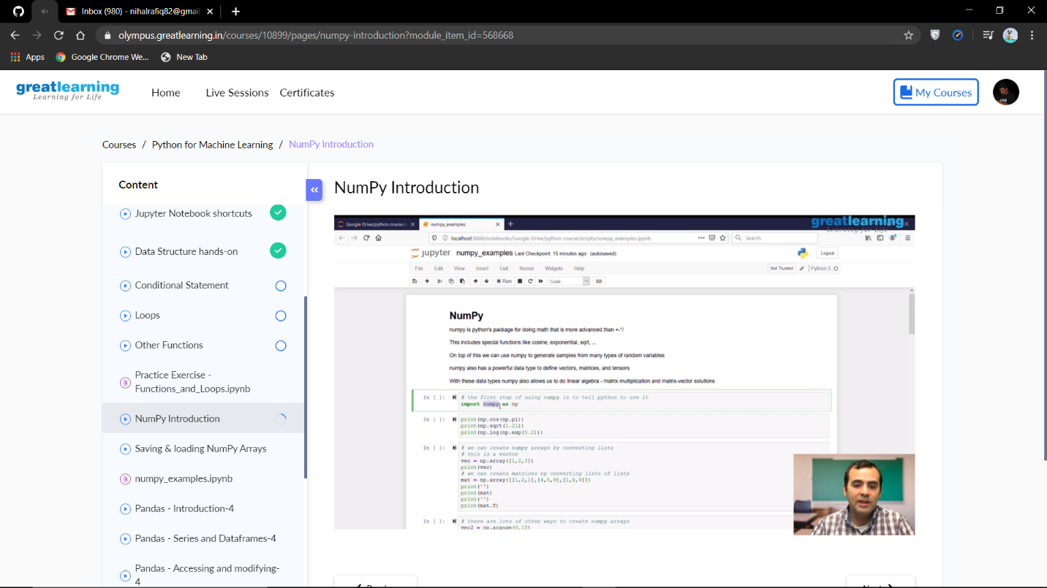

Coding Challenges Details:

1. Write a java program to find duplicate character in a string

